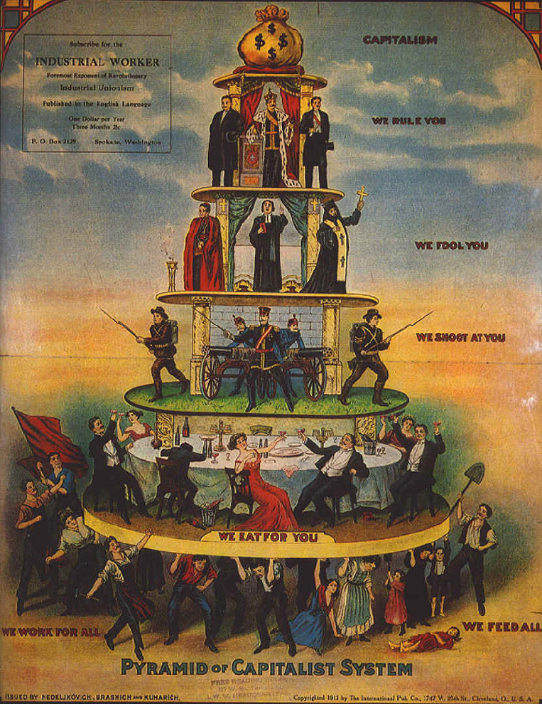
A 1911 Industrial Worker (IWW newspaper)

